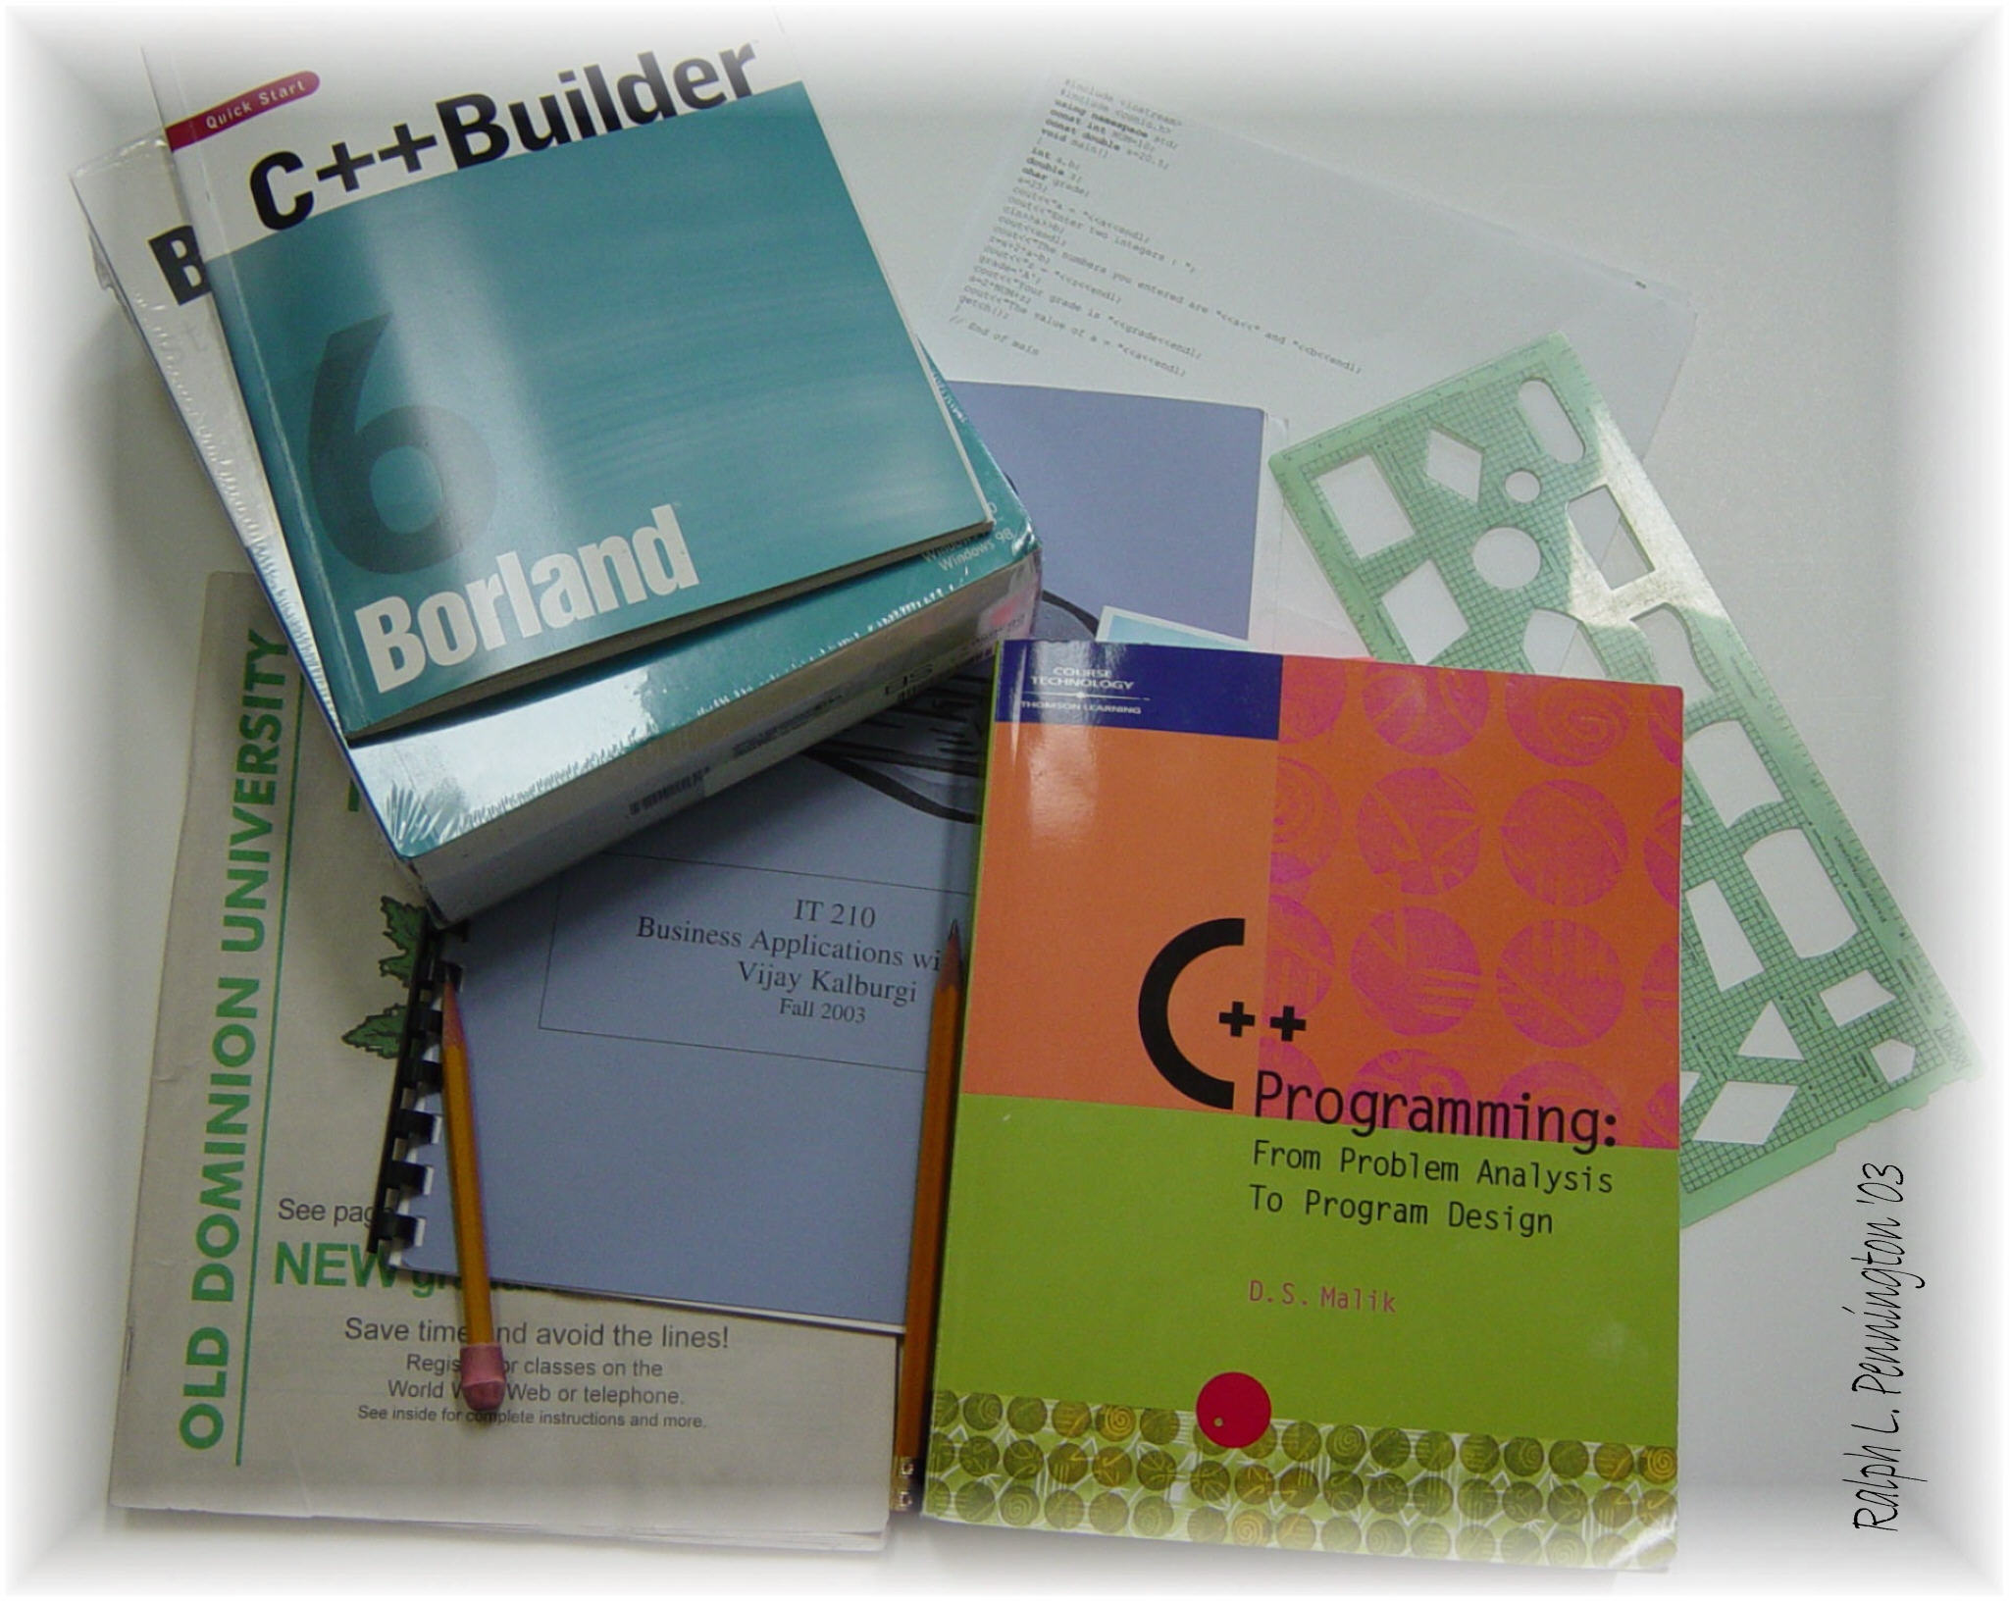

Michael Ragsdale
IT210 Business Applications with C++
TR 11:00 – 12:15 PM
Instructor: Vijay Kalburgi

Program Assignment 4

Credit Card Record System 2.0
Fall 2014

Michael Ragsdale

00978282

Credit Card Record System 2.0

November 20th, 2014

